Khuzaima Mushtaq  
CSS 430

# Project 3 Report

## Cache Specs/ Design:

This section explains my Cache design and specification, including the Enhanced Second Chance algorithm. To start off, my Cache uses a CacheEntry private subclass to hold each CacheEntry. Each CacheEntry has a byte[] DATA, an int frameNo for corresponding disk block, and Booleans for useBit and modifiedBit. Using the CacheEntry class I made a CacheEntry[] Array that holds all the CacheEntry’s. I also have private ints pageSize for blocksize, cacheSize for total number of CacheEntry’s, and scPtr which is the Second Chance pointer.

For the Read and Write Methods my algorithm is very similar. Firstly, I check to see if the blockId is out of bounds, then I check to see if the blockId is in the Cache already, if Entry is already in cache I perform the action Read/Write and update useBit/ modifiedBit as needed. If entry is not in Cache then I Check if there is an open CacheEntry and use that, if not, I use my findVictim() Method to find an entry to remove as specified by the Second Chance algorithm. When overwriting CacheEntry’s I check if the modifiedBit is set and write to disk if needed.

My Enhanced Second Chance algorithm is based on sets of 2 while loops. In the First while loop I check if there are any entry’s that are u = 0 and m = 0 I also do not change any u = 1 to 0. IF this loop does not find an entry to replace then I hop into second loop. In the second while loop I check for u = 0 and m =1 and also set any 1’s to 0 as I go through. IF, even after this I do not have an entry to replace I reset to the starting second chance pointer and do loops 1 and 2 again which are guaranteed to find a match because the second loop puts 1’s to 0’s.

## Performance Tests:

This section discusses the results of using a Cache vs not in regard to the 4 different test cases. For all my test I do 1000 writes and 1000 reads. I create a byte double array as byte[1000][512] and use that reading/writing For all tests the enabled and disabled tests are the same except that I use cread vs rawread and cwrite cs rawwrite. The times below are in Microseconds. For comparison 53614365 microseconds is ~53.614 seconds.

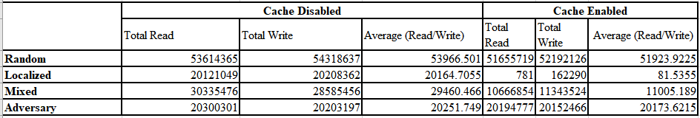

### ONE: Random Access

For my Random test I use Math.random() *999 + 0 to randomize the blockId for the reads and the writes and do this 1000 times. As for the performance Evaluation, the results are as expected. Since the Random Access really does not use the Cache it is obvious that the performance would not be increased much if at all.

### TWO: Localized

For the Localized test I go through a loop 1000 times and read/write to only blockId’s 1-10 using I %10. This leads to almost 100% Cache hit rate. The performance evaluation for this test was the most surprising. The speed increase is insane, many degrees faster. Up to 10000 time faster. This also makes sense though because the OS has to never access the Disk it has an almost 100% hit rate on the Cache aside from the first 10 lookups, which account for the increased time for the Total Write.

### THREE: Mixed

For my mixed test I combine my Random and Localized such that 10% of the time I do a random access and the rest of the time I access BlockId’s 1-10. The performance is as predicted for this test as well. The use of the cache in the localized hits ~90% of the time show a 10-20x faster speed.

### FOUR: Adversary

For my Adversary Test I do a sequential read/Write such that there is never a Cache Hit because we are trying to access a different BlockId Everytime 1-1000. For this one there isn’t a significant difference between the enabled and disabled tests again because the Cache is not used since we do not hit it at all.

### OVERALL Performance:

Overall, I was surprised by Localized test and the Random Test the most. The random test takes significantly longer than even the Adversary Test, I can only imagine that this is because of the Random element adding overhead to the reads/writes. Since the program has to calculate random numbers a lot of times. Otherwise the results are as expected between the disabled and enabled versions of the tests!

Linux Test Screen Shot Below!

## Results Linux Screenshot:

